EE5630 DSP f2020 HW# 3 (ch.4) Due 15:30, 11/12/2020

1. (10%)

Consider the system shown below.



The anti-aliasing filter is a continuous-time filter with the frequency response *L*(*j*)

**

The frequency response of the LTI discrete-time system between the converters is given

by: *Hd*(*ej*) = exp(-*j*/3), |**|<.

(a) What is the effective continuous-time frequency response of the overall system, *H*(*j*)?

(b)Choose the most accurate statement:

(i) *yc*(*t*) = *d*/*dt*{*xc*(3*t*)}

(ii) *yc*(*t*) = *xc*(*t-T/*3)}

(iii) *yc*(*t*) = *d*/*dt*{*xc*(*t*-3*T*)}

(iv) *yc*(*t*) = *xc*(*t*-1/3)}

(c) Express *yd*[*n*]in terms of *yc*(*t*)*.*

(d) Determine the impulse response *h*[*n*] of the discrete-time LTI system.

2. (10%)

For the system shown below, assume that *Xc*(*j*) = 0, II ≥ /*T*1*.* For the general case in which *T*1 ≠ *T*2 in the system, express *yc*(*t*)in terms of *xc*(*t*)*.* Is the basic relationship different for *T*1 > *T*2 and *T*1 < *T*2?



3. (10%)

Consider the system shown below where *rc*(*t*) is a bandlimited signal with *Rc*(*j*) = 0 for || ≧ 1000rad/s, and *H*(*ej*) is an ideal lowpass with cutoff frequency **0<.

(a) What is the Nyquist frequency and Nyquist rate of this system? Does aliasing occurs in this system?

(b) Sketch *S*(*ej*), *Su*(*ej*), *Sf*(*ej*) and Sr(*ej*).

(c) Choose nonzero values for **0 and *T*2 such that *sf*[*n*] = *rc*(*nT*2) for some nonzero constant **.

(d) Using the value of **0 in (c), determine a choice for *T*3 such that *sc*(*t*) = *rc*(*t*) for some nonzero constant .

*sc*(*t*)

*rc*(*t*)

C/D

↑3

*H*(*ejw*)

↓2

*sr*[*n*]

*sf*[*n*]

*su*[*n*]

*s*[*n*]

*T*1 = 1ms

1000

-1000

 (rad/s)

*Rc*(*j*)

6

D/C

*T*3

4. (10%)

Consider the system shown below where . Sketch *Yc*(*j*) if *Xc*(*j*) is shown below. (assume *L* = 4)

*xc*(*t*)

C/D

↑*L*

*H*(*ej*)

*y*[*n*]

*w*[*n*]

*v*[*n*]

*x*[*n*]

*T*

**

-**

 (rad/s)

*Xc*(*j*)

1

D/C

*T'=T/L*

x

(-1)*n*

*yc*(*t*)

5. (10%)

The block diagram below represents a system that we would like to implement. Determine a block diagram of an equivalent system consisting of a cascade of LTI systems, compressor blocks and expander blocks which results in the minimum number of multiplications per output sample.

Note: By “equivalent system”, we mean that it produces the same output sequence for any given input sequence.

↑3

↓2

↓2

H(z)

↑3

x[n]

y[n]



6. (10%)

Consider the two systems shown below.

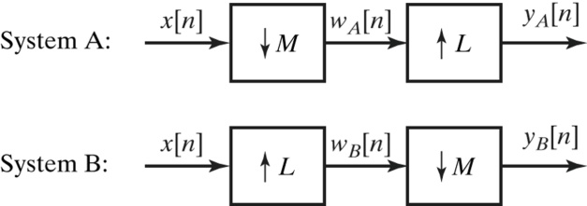

(a) For *M*=2, *L*=3, and any arbitrary *x*[*n*], will *yA*[*n*] = *yB*[*n*]? If your answer is yes, justify your answer. If your answer is no, clearly explain or give a counter example.

(b) How must *M* and *L* be related to guarantee *yA*[*n*] = *yB*[*n*] for any arbitrary *x*[*n*]?

7. (10%)

We wish to compute the autocorrelation function of an upsampled signal, as indicated in the following figure (a). It is suggested that this can equivalently be accomplished with the system in (b). Can *H*2(*ej*) be chosen so that 3[*m*] = 1[*m*]? If not, why not? If so, specify *H*2(*ej*).

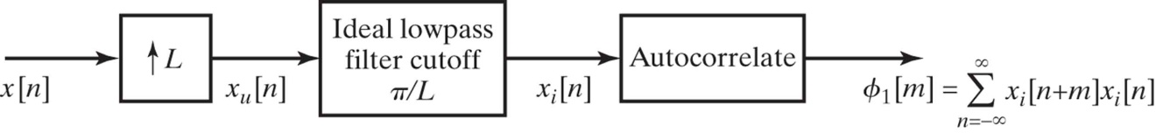

(a)

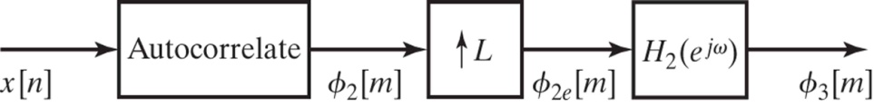

(b)

8. (10%)

The following are three proposed identities involving compressors and expanders. For each, state whether or not the proposed identity is valid. If your answer is that it is valid, explicitly show why. If your answer is no, explicitly give a simple counterexample.

Proposed identity (a)

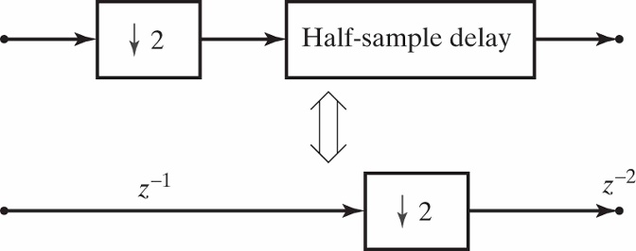

Proposed identity (b)

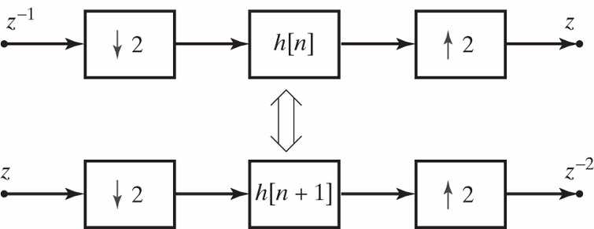

Proposed identity (c)

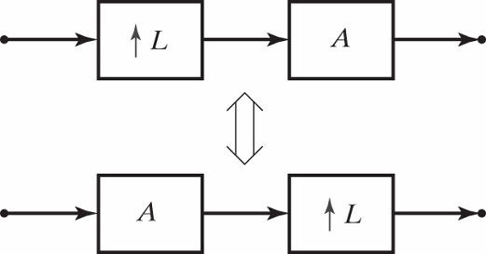

where *L* is a positive integer, and *A* is defined in terms of *X*(*ej*) and *Y*(*ej*) (the respective DTFTs of *A*’s input and output) as: *Y*(*ej*) = (*X*(*ej*))*L*.

9. (10%)

(a) A finite sequence *b*[*n*] is such that *B*(*z*) + *B*(-*z*) = 2*c*, *c* ≠ 0. Explain the structure of *b*[*n*]. Is there any constraint on the length of *b*[*n*]?

(b) Is it possible to have *B*(*z*) = *H*(*z*)*H*(*z*-1)? Explain.

(c) A length-*N* filter *H*(*z*) is such that *H*(*z*)*H*(*z*-1) + *H*(-*z*)*H*(-*z*-1) = *c*. Find *G*0(*z*) and *G*1(*z*) such that the filter shown below is LTI.

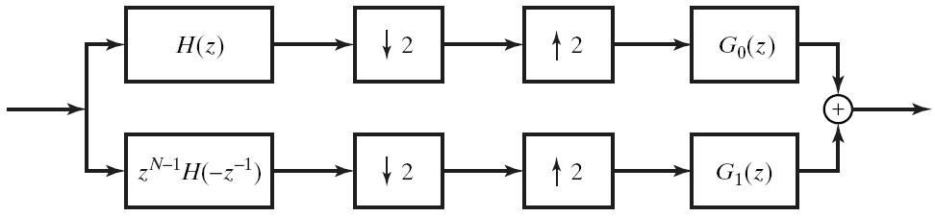

10. (10%)

Consider the multirate system shown below with input *x*[*n*] and output *y*[*n*]:

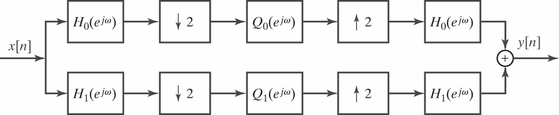

where *Q*0(*ej*) and *Q*1(*ej*) are the frequency response of two LTI systems. *H*0(*ej*) and *H*1(*ej*) are ideal lowpass and highpass filters, respectively, with cutoff frequency at ** = /2 as shown below.

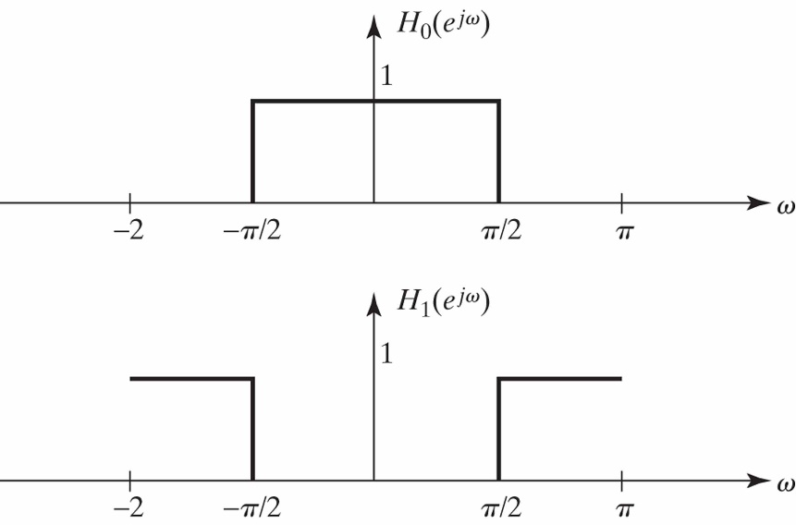

The overall system is LTI if *Q*0(*ej*) and *Q*1(*ej*) are as shown below.

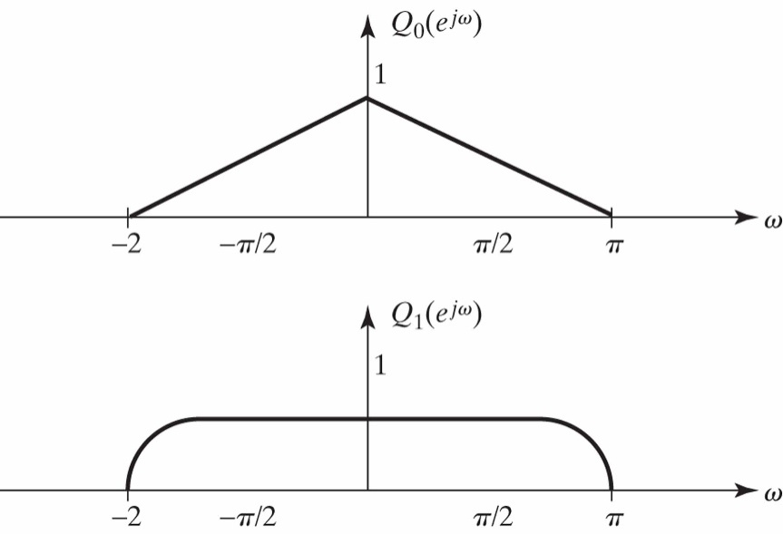

For these choices of *Q*0(*ej*) and *Q*1(*ej*), sketch the frequency response *G*(*ej*) of the overall system.